1
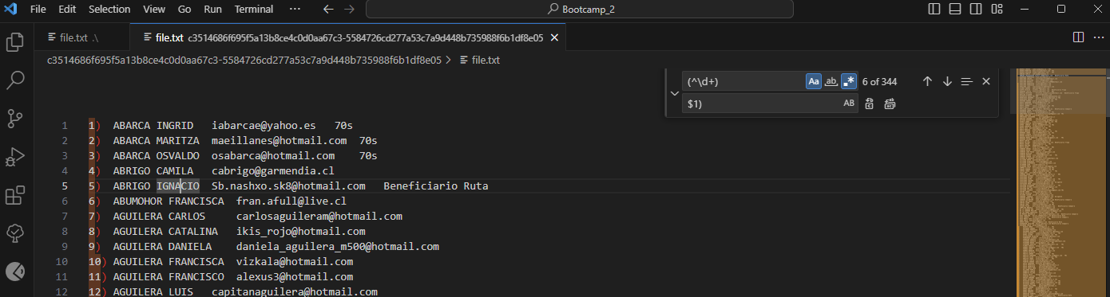
(^\d+)
$1)

2

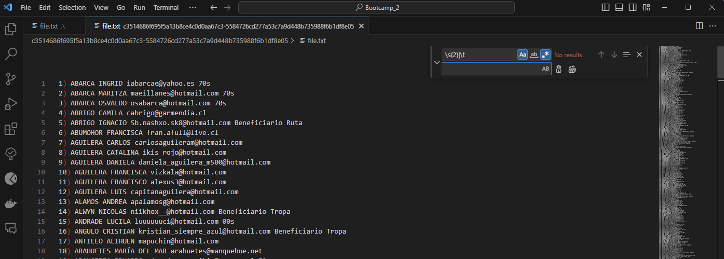
\s{2}|\t
‘ ‘

3
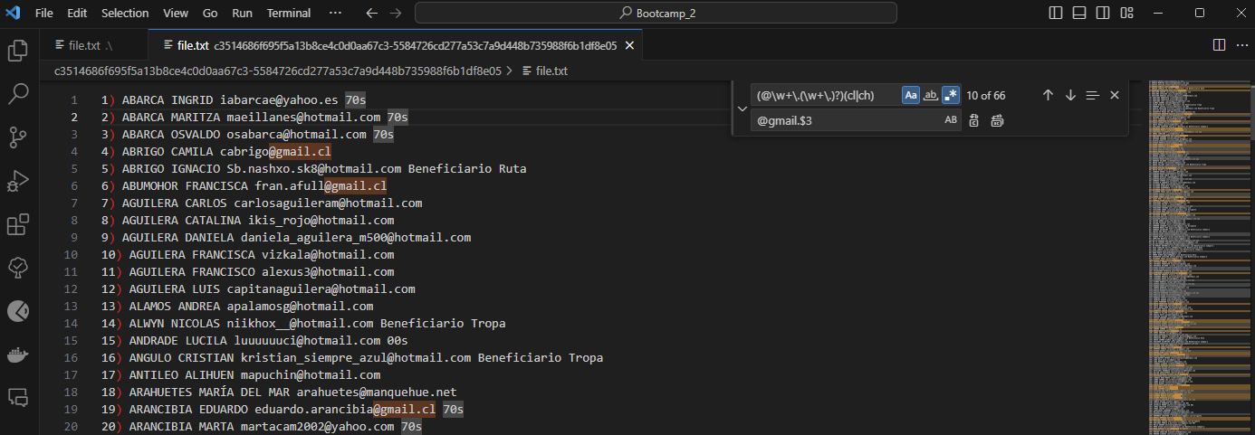
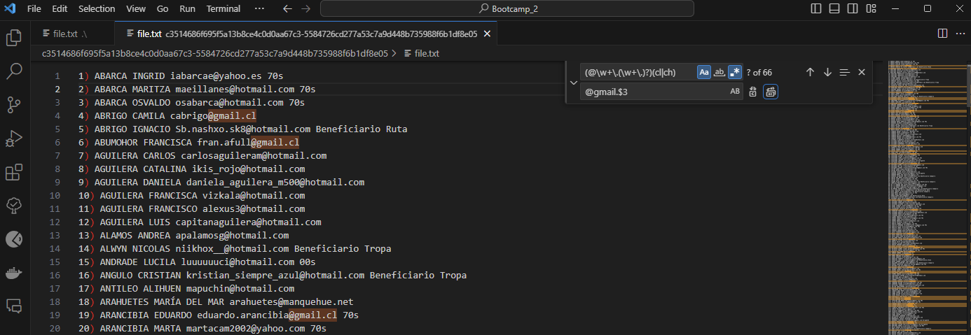
(@\w+\.(\w+\.)*)(cl|ch) → @gmail.$3
(@[\w\.-]+\.)(cl|ch) → @gmail.$2

4

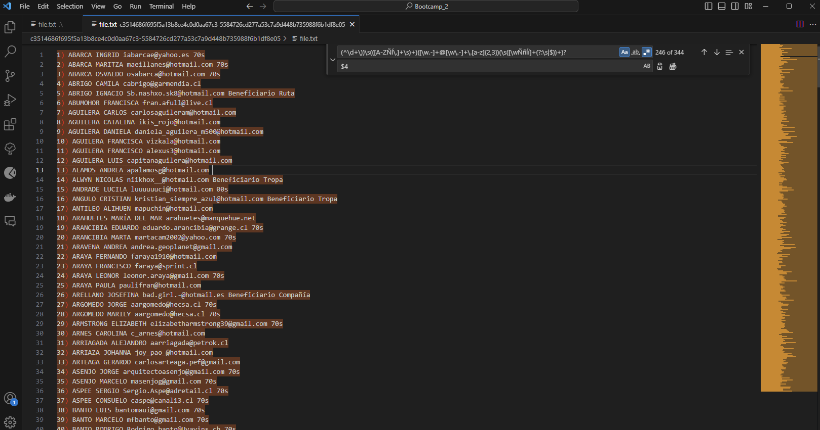
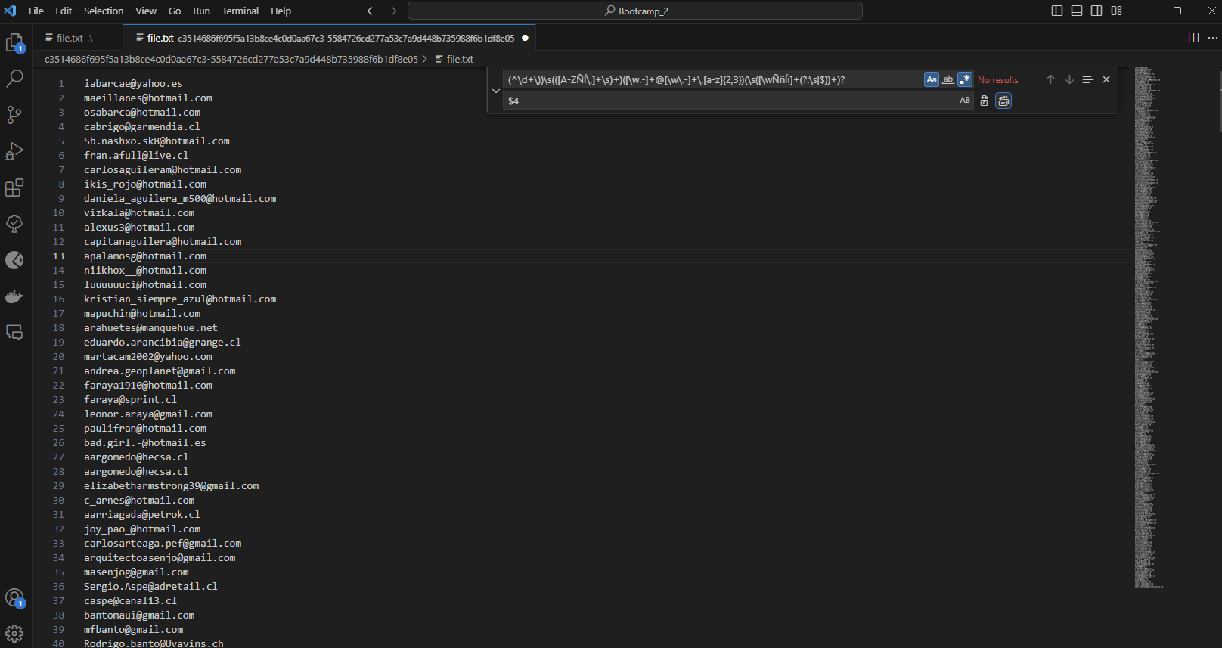

(^\d+\))\s(([A-ZÑñÀ-ÿ \.]+\s)+)([\w.-]+@[\w\.-]+\.[a-z]{2,3})(\s([\wÑñÀ-ÿ ]+(?:\s|$))+)? → $4
.*\s(@\w+\.\w+).+

5

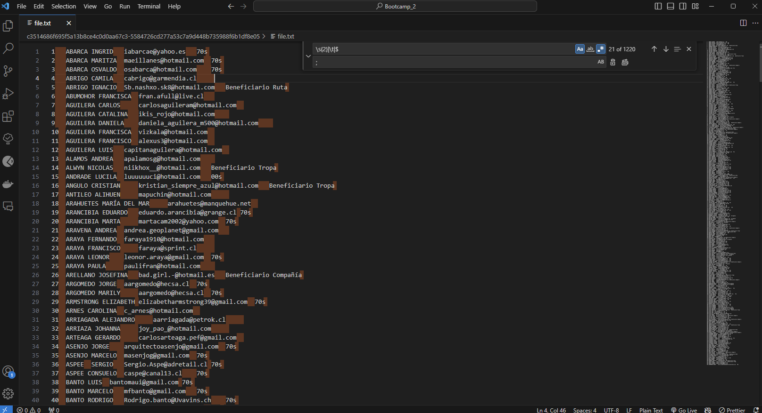

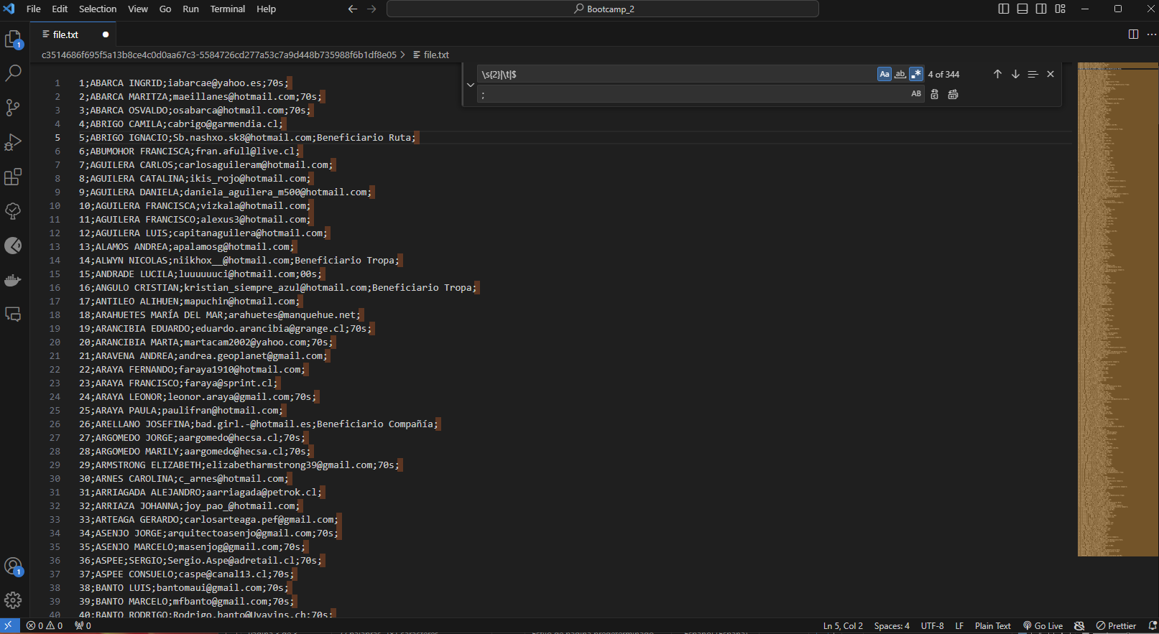
\s{2}|\t|$ → ;
\s|$ → ;

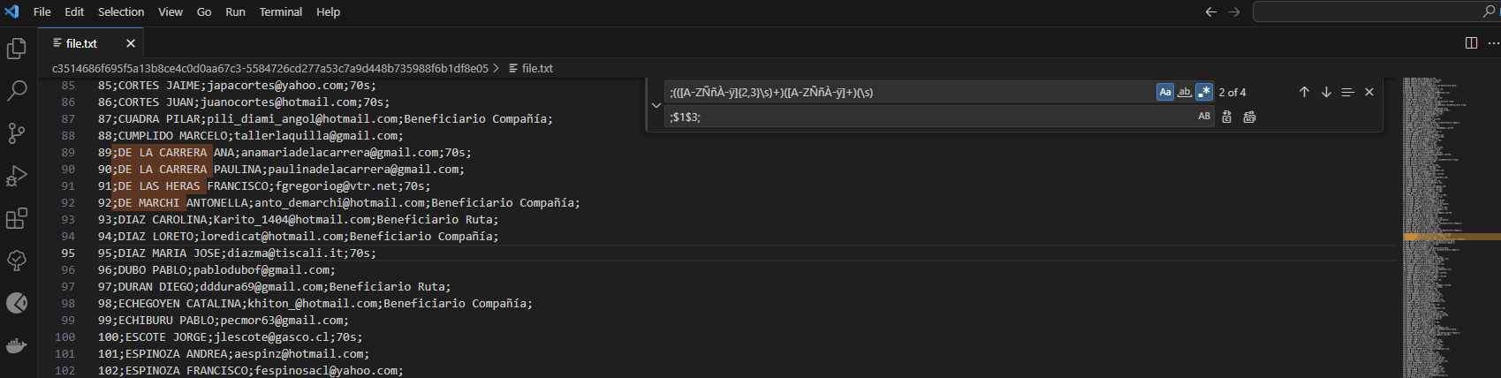

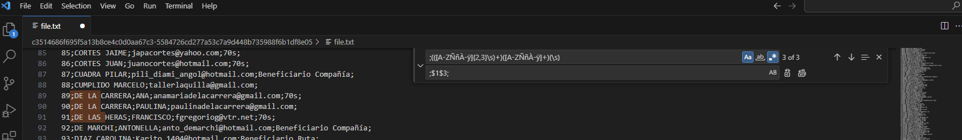
;(([A-ZññÀ-ÿ]{2,3}\s)+)([A-Z<ÑñÀ-ÿ]+)(\s) → ;$1$3;

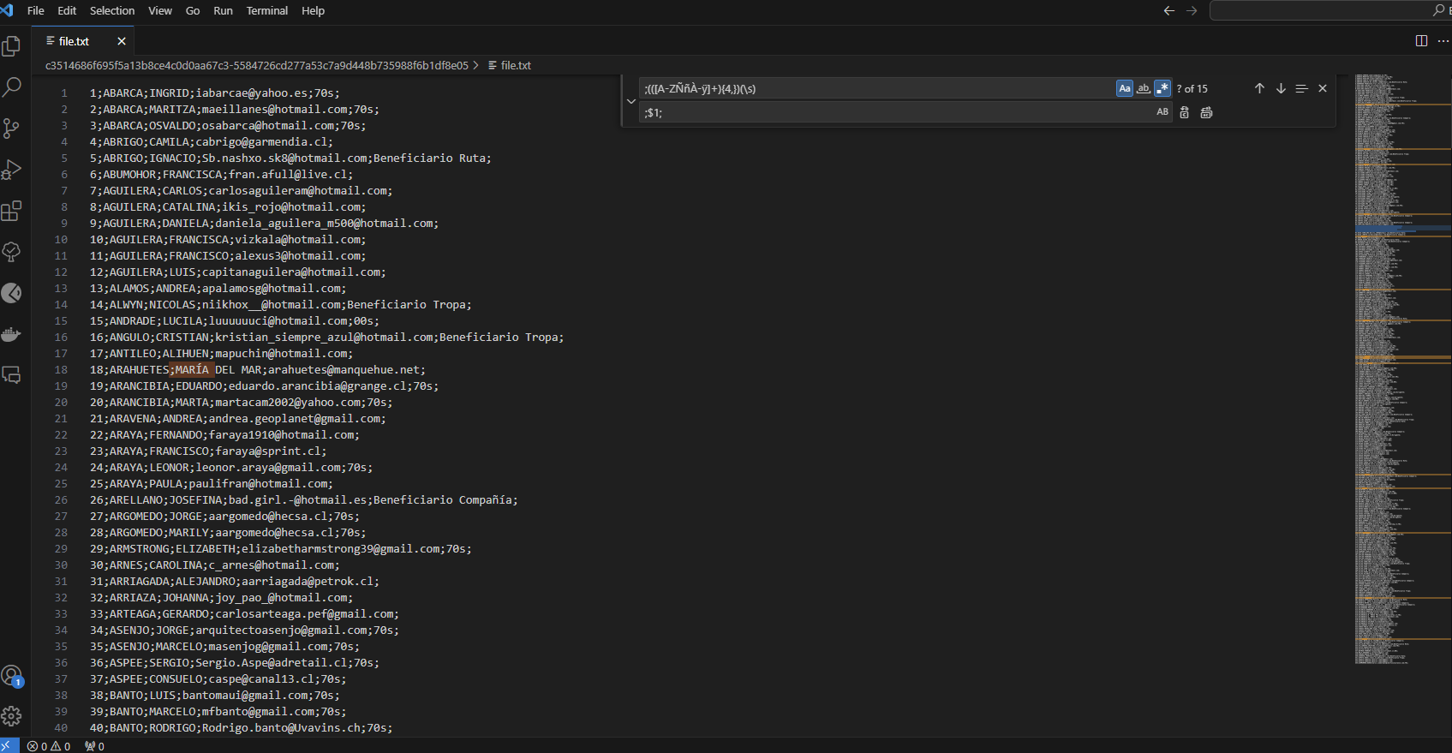



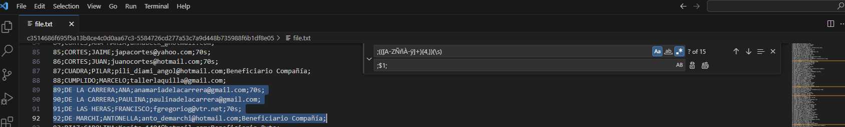

;(([A-ZÑñÀ-ÿ]+){4,})(\s) → ;$1;

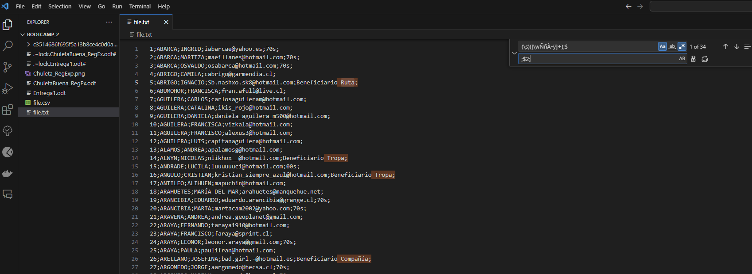
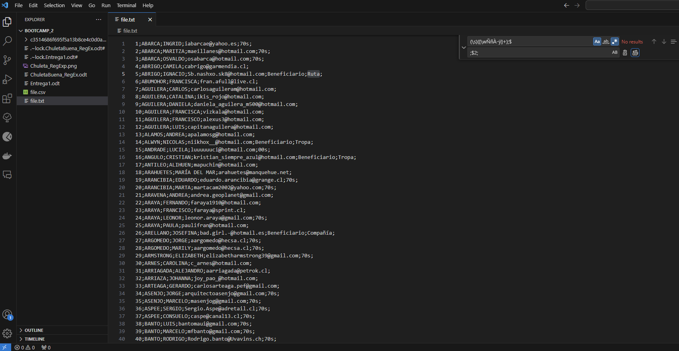

(\s)([\wÑñÀ-ÿ]+);$ → ;$2;

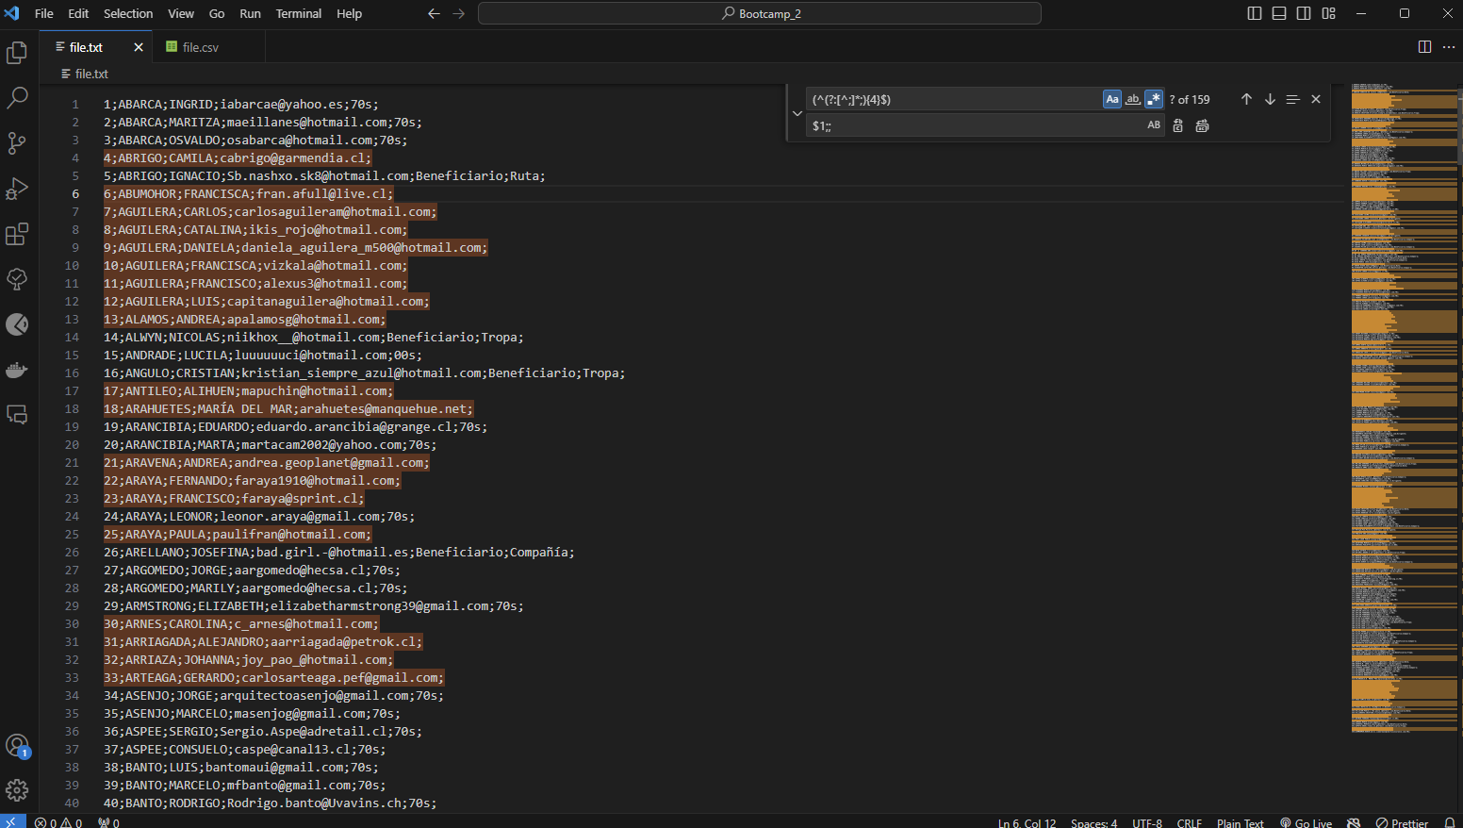

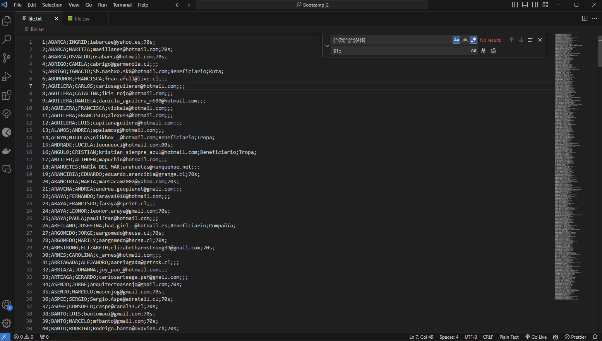

(^(?:[^;]*;){4}$) → $1;;


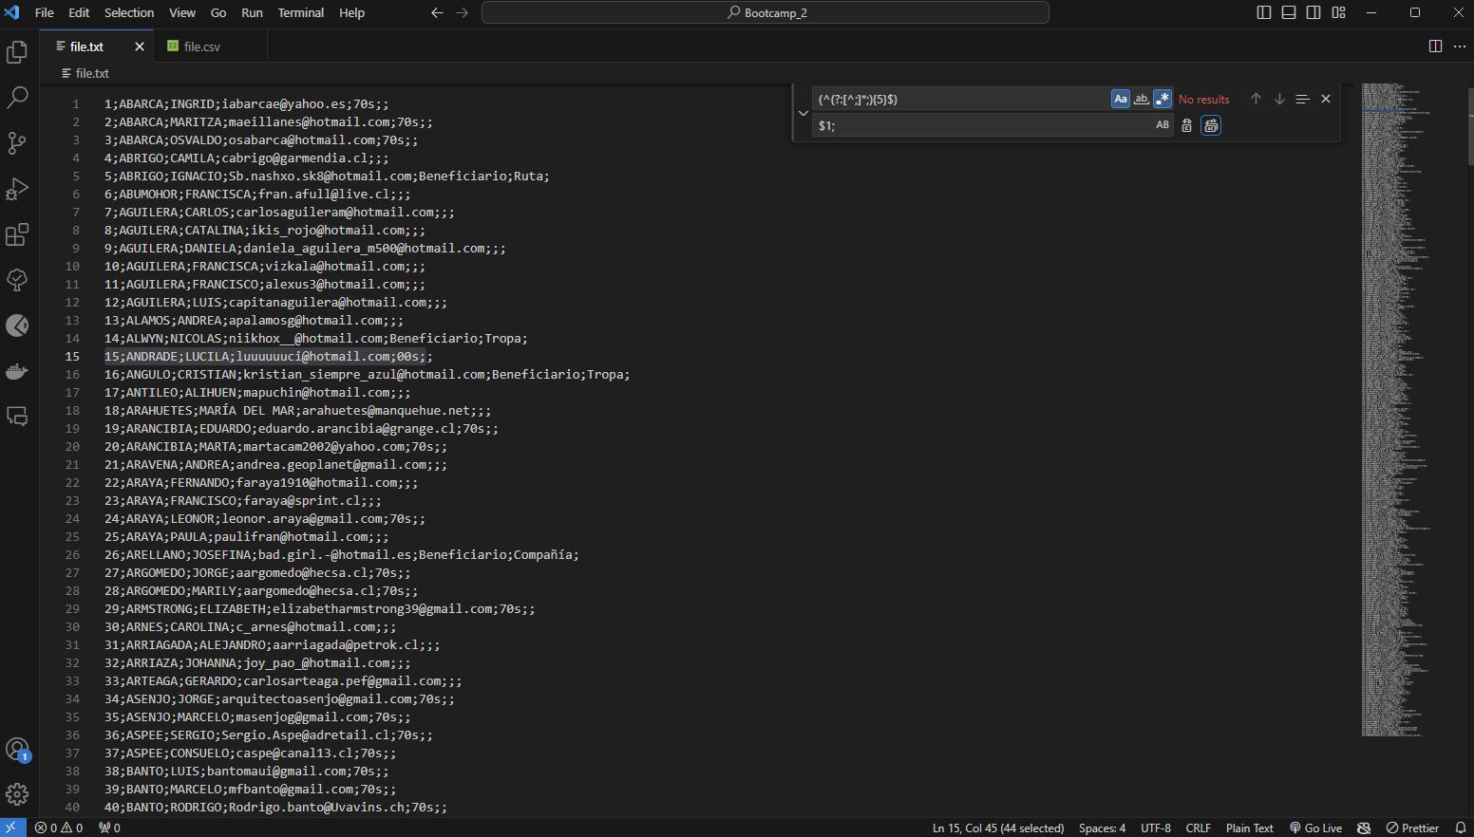

(^(?:[^;]*;){5}$) → $1;

